*Sum and avg the argument must be of type numeric*

*• Except for the special case COUNT(*), the argument may be preceded by the key word DISTINCT to eliminate the duplicate rows before the function is applied to a column.*

*• The special function COUNT(*) which is used in all rows without any duplicate elimination, and so the key*

*• The argument cannot involves any aggregate function references or table expressions at any level of*

*nesting*

*- For example the SQL select Avg(min(qty)) as average is illegal.*

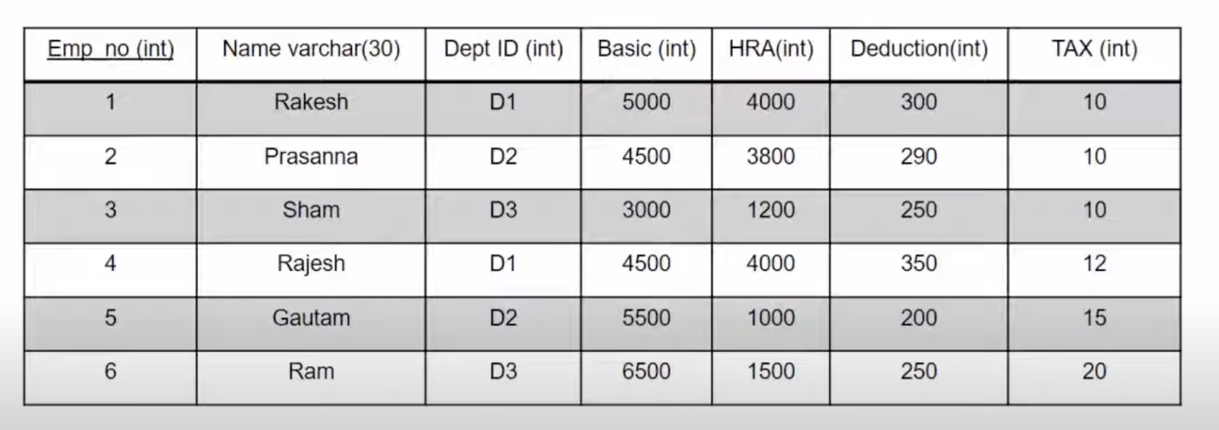

|  |  |  |
| --- | --- | --- |
| *Column Name* | *Data Type* | *Description* |
| *Emp_no* | *int* | *Employee Number* |
| *Name* | *varchar(30)* | *Employee Name* |
| *Dept_ID* | *varchar(10)* | *Department ID* |
| *Basic* | *int* | *Basic Salary* |
| *HRA* | *int* | *House Rent Allowance* |
| *Deduction* | *int* | *Deduction* |
| *TAX* | *int* | *Tax* |

|  |  |  |  |  |  |  |
| --- | --- | --- | --- | --- | --- | --- |
| Emp_no | Name | Dept_ID | Basic | HRA | Deduction | TAX |
| 1 | Rakesh | D1 | 5000 | 4000 | 300 | 10 |
| 2 | Prasanna | D2 | 4500 | 3800 | 290 | 10 |
| 3 | Sham | D3 | 3000 | 1200 | 250 | 10 |
| 4 | Rajesh | D1 | 4500 | 4000 | 350 | 12 |
| 5 | Gautam | D2 | 5500 | 1000 | 200 | 15 |
| 6 | Ram | D3 | 6500 | 1500 | 250 | 20 |

SQL

-- Create a new database (if not already created)

CREATE DATABASE IF NOT EXISTS EmployeeDatabase;

-- Select the database to use

USE EmployeeDatabase;

-- Create a new table with the specified schema

CREATE TABLE Employee (

Emp_no INT,

Name VARCHAR(30),

Dept_ID VARCHAR(10),

Basic INT,

HRA INT,

Deduction INT,

TAX INT

);

|  |  |  |
| --- | --- | --- |
| *Column Name* | *Data Type* | *Description* |
| *Emp_no* | *int* | *Employee Number* |
| *Name* | *varchar(30)* | *Employee Name* |
| *Dept_ID* | *varchar(10)* | *Department ID* |
| *Basic* | *int* | *Basic Salary* |
| *HRA* | *int* | *House Rent Allowance* |
| *Deduction* | *int* | *Deduction* |
| *TAX* | *int* | *Tax* |

-- Optionally, you can insert the provided data into the table

INSERT INTO Employee (Emp_no, Name, Dept_ID, Basic, HRA, Deduction, TAX) VALUES

(1, 'Rakesh', 'D1', 5000, 4000, 300, 10),

(2, 'Prasanna', 'D2', 4500, 3800, 290, 10),

(3, 'Sham', 'D3', 3000, 1200, 250, 10),

(4, 'Rajesh', 'D1', 4500, 4000, 350, 12),

(5, 'Gautam', 'D2', 5500, 1000, 200, 15),

(6, 'Ram', 'D3', 6500, 1500, 250, 20);

|  |  |  |  |  |  |  |
| --- | --- | --- | --- | --- | --- | --- |
| Emp_no | Name | Dept_ID | Basic | HRA | Deduction | TAX |
| 1 | Rakesh | D1 | 5000 | 4000 | 300 | 10 |
| 2 | Prasanna | D2 | 4500 | 3800 | 290 | 10 |
| 3 | Sham | D3 | 3000 | 1200 | 250 | 10 |
| 4 | Rajesh | D1 | 4500 | 4000 | 350 | 12 |
| 5 | Gautam | D2 | 5500 | 1000 | 200 | 15 |
| 6 | Ram | D3 | 6500 | 1500 | 250 | 20 |

select * from Employee;

desc Employee;

select count(*) from Employee;

select count(name) from Employee;

select count(dept_id) from Employee;

select count(distinct dept_id) from Employee;

-- number of employees in department d1 with salary < 6000

select count(name)

from Employee

where dept_id = 'D1' and Basic < 6000;

select * from Employee

where dept_id = 'D1' and Basic= 4500;

SET SQL_SAFE_UPDATES = 0;

update Employee

SET Basic = 45000

Where dept_id = 'D1' and Basic = 4500;

SET SQL_SAFE_UPDATES = 1;

UPDATE Employee

SET Basic = 45000

WHERE dept_id = 'D1' AND Basic = 4500

LIMIT 1;

-- find the total basic pay for all the employees in the organization

select sum(basic)

from Employee;

update Employee

set basic = 4500

where dept_id = 'D1' And basic = 45000

limit 1;

-- find the total pay in department d2 for all employees whose basic pay is more that 4000

select sum(basic)

from employee

where dept_id = 'D2' and basic>4000;

-- find the total pay for all the employees (basic +hra -deductins)

select sum(Basic+ HRA - Deduction - TAX) as 'Total Pay'

from Employee

where dept_id = 'D3';

-- find the total pay for all the employees (basic +hra -deductins) from dept d1 salary > 4500

select sum(Basic+ HRA - Deduction - TAX) as 'Total Pay'

from Employee

where Dept_id = 'D1' and basic>4500;

-- average hra

select avg (HRA)

from Employee;

-- average pay in department d1 whose HRA > 1000

select avg (Basic+ HRA - Deduction - TAX)

from Employee

where dept_id = 'D1' and HRA> 1000;

-- find the department wise average pay of the employees

select dept_id, Avg (Basic+ HRA - Deduction - TAX) as Avg_Pay

from Employee

group by dept_id;

-- find all the employees whose basic pay is greater that the average basic pay

select avg (Basic) from Employee e2;

select e1.NAME as Name, e1.Basic as Basic

from Employee e1

where Basic > (select avg (Basic) from Employee e2) ;

-- find the maximum basic pay of the employee

select name, Basic

from employee

where basic = (select max(Basic)

from Employee);

-- find the average , maximum and minimum basic of all the departments except department d1

select dept_id, avg(Basic+HRA-Deduction - Tax) as average_pay, MAX(Basic + HRA - Deduction - TAX) AS Maximum,

MIN(Basic + HRA - Deduction - TAX) AS Minimum

from Employee

where dept_id <> 'D1'

group by (dept_id) ;

--- Exercises

* What is the name of the employee who draws the maximum salary?
* What is the total amount that the company spends on salary?
* What is the salary break-up per department?
* What is the average salary of an employee in the company?
* What is the average salary of each department?